- Problem: Different types of Convolution Mode

Logical Solution:
- y(n)=$\sum_{k=-∞}^{∞}{x\left(n\right)*h(n-k)}$
- Full all possible combinations,
- Same same length of larger input.
- Valid where all the signal values are engaged for calculation.

Source Code:
import numpy as np
import matplotlib.pyplot as plt

x_n=np.array([4,8,9,10])
h_n=np.array([1,1,1,1])
h0=0
y_n=np.convolve(x_n,h_n,'full')
length=len(y_n)
t=[i for i in range(length)]

plt.grid(True)
plt.stem(t,y_n)
plt.show()

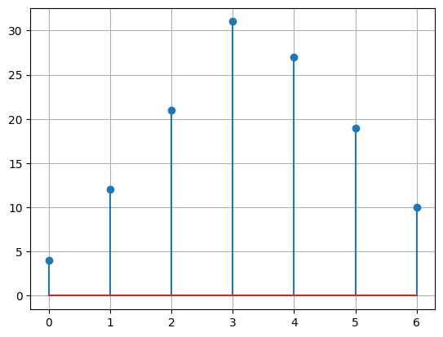
Figure-Full Mode Convolution
y_n=np.convolve(x_n,h_n,'same')
length=len(y_n)
t=[i for i in range(length)]

plt.grid(True)
plt.stem(t,y_n)
plt.show()

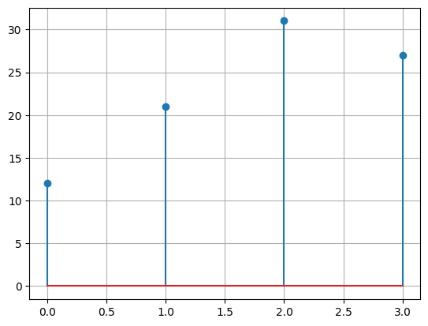
Figure- Same Mode Convolution

y_n=np.convolve(x_n,h_n,'valid')
print(y_n)
length=len(y_n)
t=[i for i in range(length)]

plt.grid(True)
plt.stem(t,y_n)
plt.show()

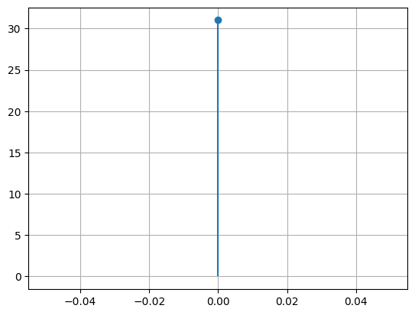
Figure- Valid Mode Convolution

Discussion:
- Using built-in convolution function I have implemented the different kinds of convolution mode.

- Problem: Edge Detection using Convolution

Logical Solution:
- y(n)=$\sum_{k=-∞}^{∞}{x\left(n\right)*h(n-k)}$

Source Code:
import numpy as np
import matplotlib.pyplot as plt

x0=[0]*15
x1=[1]*15
x_n=x0+x1+x0+x1+x0+x1+x0
kernel=[1,-1]
edges=np.convolve(x_n,kernel)

fig,(ax1,ax2)=plt.subplots(2,1,figsize=(9, 8))
ax1.stem(x_n)
ax1.set_title("Original Signal x[n]")
ax1.grid(True)

ax2.plot(edges)
ax2.set_title("Edge Detection Output")
ax2.grid(True)

plt.tight_layout()
plt.show()
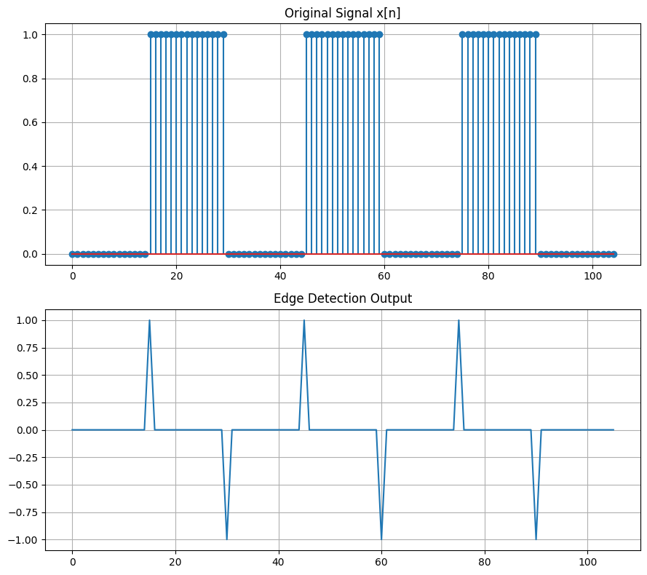
Output- Edge Detection of sharp Transition

Discussion:
- Using matplotlib library and Built-in numpy function I have figured out the spike of the edge.

- Problem: Different Kinds of Correlation

Logical Solution:
- r_{xy}(n)=$\sum_{k=-∞}^{∞}{x\left(k\right)*h(k-n)}$

Source Code:
import numpy as np
import matplotlib.pyplot as plt

def correlation(x,x0,y,y0):
t=[]
rxy=[]
# rxy(n)= sum(k=-inf to inf) x(k)*y(k-n)
mx=max(len(x),len(y))
for n in range(-mx,mx+1):
rxy.append(0)
t.append(n)
for k in range(-mx,mx+1):
try: # if positive index exist?
if k>=(-x0): a=x[k+x0] # if negative index exists?
else: a=0
except: a=0

try:
if (k-n)>=(-y0): b=y[k+y0-n]
else: b=0
except: b=0

rxy[-1]+=a*b

return t,rxy

# Auto-correlation

x=np.array([1,3,5,7])
x0=0
t,rxy=correlation(x,x0,x,x0)

plt.stem(t,rxy)
plt.grid(True)
plt.show()

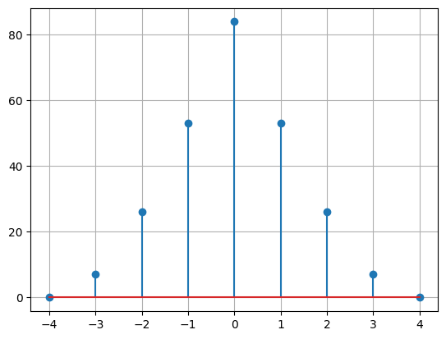
Output- Auto-Correlation

# cross-corelation:

x=np.array([2,3,5,7])
x0=0
y=np.array([1,1,3,7,9,13,2])
y0=0
t,rxy=correlation(x,x0,y,y0)
plt.stem(t,rxy)
plt.grid(True)
plt.show()

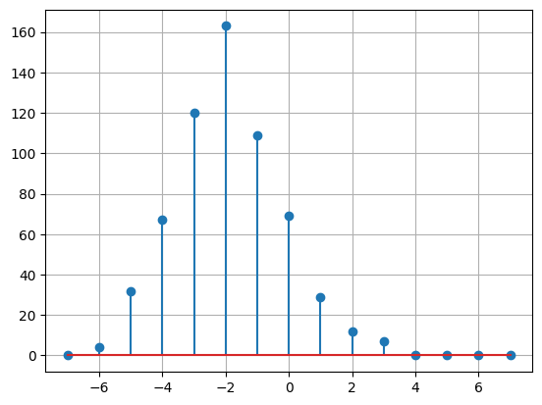
Output- Cross Correlation

# Auto Correlation using built-in function
f=1
t=np.linspace(-1,1,1000)
sinx=np.sin(2*np.pi*f*t)
cosx=np.cos(2*np.pi*f*t)

plt.plot(sinx)
plt.plot(cosx)
plt.grid(True)
plt.legend(('sin(x)','cos(x)'))
plt.title("Periodic Signal")
plt.show()

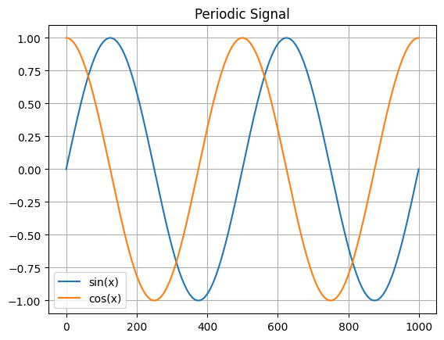
Output- sine-cosine signal

# Sine Auto-correlation
auto_correlate=np.correlate(sinx,sinx,mode='full')

plt.plot(auto_correlate)
plt.title("Auto-correlation of Sine Wave")
plt.grid(True)
plt.show()

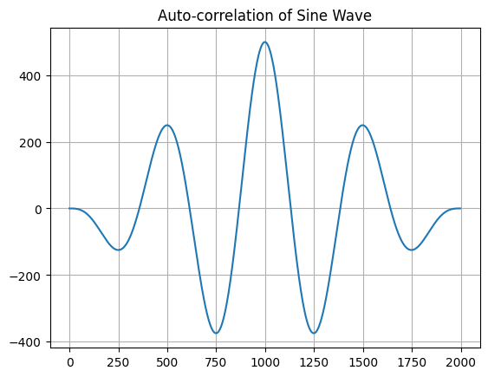
Output- Auto-correlation of Sine signal

# Cosine Auto-correlation
auto_correlate=np.correlate(cosx,cosx,mode='full')

plt.plot(auto_correlate)
plt.title("Auto-correlation of Cosine Wave")
plt.grid(True)
plt.show()

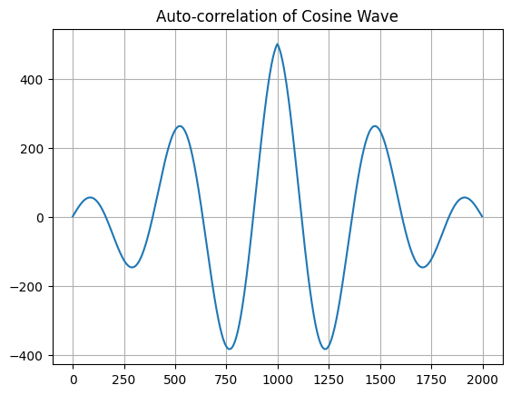
Output- Auto-correlation of Cosine signal

Discussion:
- I have implemented the auto and cross correlation for normal signal value and periodic signal value.

